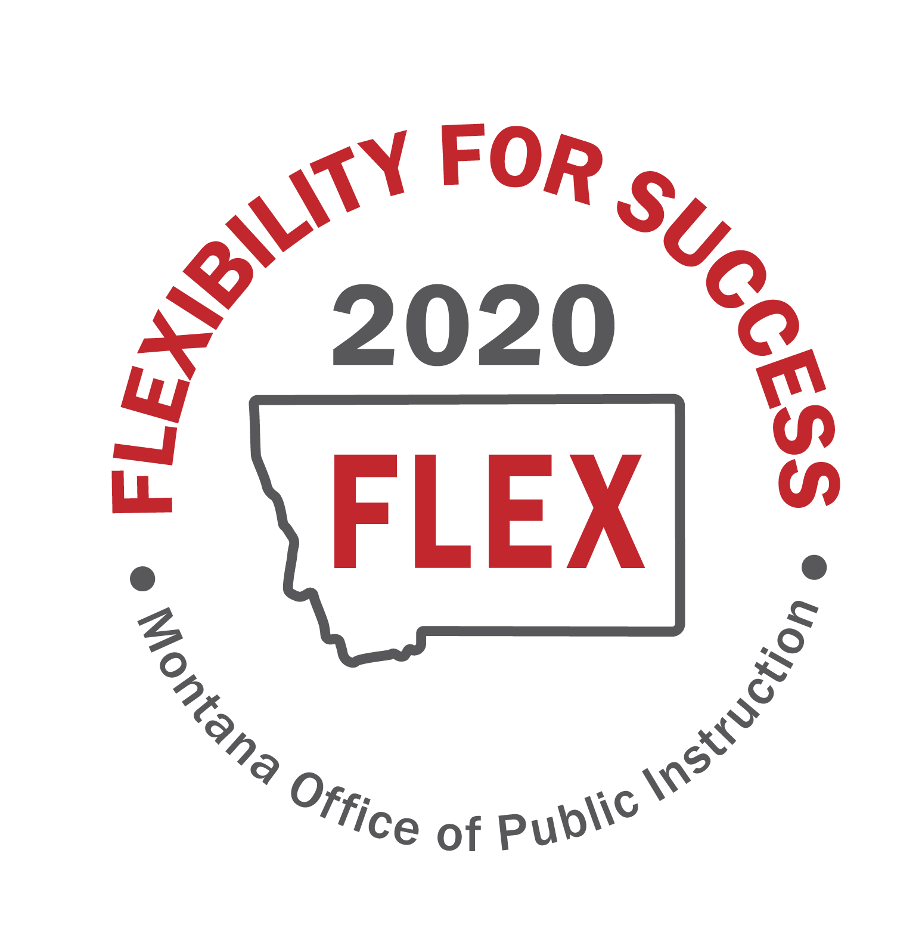

“MT FLEX2020” Task Force
Session 3
June 10, 2020
Focus Group Pre-work

Focus Group: D-Fostering and supporting local innovation
Note Taker: Lona Running-Wolf
Group Members: Dinny Bennett, Forsyth Public Schools Superintendent
Michelle Halberg, Special Education Director, Gallatin-Madison Special Education Cooperative
Gregory Dern, Roy Public Schools Superintendent
Wade Sundby, Glasgow Public Schools Superintendent
Pad McCracken, Lead Staff, Education Interim Committee
Montana Legislative Services
Jon Konen, Great Falls Public Schools Principal

Group Identified Flexibilities:  - Potential Legislative Policy  - Funding Needs  - Regulation Updates  - Waiver Considerations | Draft action steps to enact these flexibilities and make them useable:  - What do we need to do?  - Who needs to be involved to enact the flexibilities?  - How long will it take to implement the flexibility?  - What are the stakeholder requirements?  - What resources would be needed?  - What are the risks involved in enacting the flexibility?  - What are the implications on student success?
1. Expand the Transformational Learning Bill for remote and blended learning models. The grant process needs to be funded in a way to have more applicants. Self-directed philosophy is needed.
2. Legislative considerations or waiver process that empowers Districts to design their own Innovative paradigm/model that fits their community needs; bundles local, state, and federal flexibilities; and provides time for school communities to plan, implement and evaluate the new paradigm.
3. Request OPI to set up regional support teams and PD for Blended Learning, Remote Learning, and Personalized Learning and Leadership Networks.
4. Develop avenues for Parent and Community Resources and Tools for Remote Learning

